Distributed Text Classification of Irish Event Listings Using TF-IDF and a Multilayer Perceptron in PySpark

Missel Ivana Garcia Uriona
MSc. Data Analytics
CCT College
Dublin, Ireland
2024365@student.cct.ie

Abstract—This paper presents an end-to-end text classification pipeline for Irish event listings built on the Hadoop Distributed File System (HDFS), Apache Spark and its machine learning library, MLlib. Event descriptions were cleaned, converted into term frequency-inverse document frequency (TF-IDF) features and classified as Event, Festival or Market with a multilayer perceptron (MLP). After duplicate descriptions were removed, 778 of the 4,038 original records remained, and the large majority belonged to the Event class. The MLP reached an accuracy of 0.887, which is below the majority-class baseline of 0.911 on the same test set, and it identified only 4 of the 10 Festival cases. The results show that the distributed workflow runs correctly from storage to model persistence, but also that a high overall accuracy can hide weak performance on minority classes. Class imbalance, model capacity relative to data size and data leakage are discussed as the main limitations.
Keywords—Big Data, Apache Spark, HDFS, TF-IDF, multilayer perceptron, class imbalance, text classification

Introduction
Tourism and event platforms publish thousands of short, unstructured descriptions every day, and placing each listing in the right category supports search, filtering and recommendation. Doing this by hand does not scale, so automatic text classification is an attractive alternative. Distributed frameworks such as Apache Spark make it possible to store, transform and model this kind of data across several machines with a single programming interface (Zaharia et al., 2016).
Ireland is a useful setting for this problem. Fáilte Ireland, the national tourism development authority, publishes its events listings as open data that is refreshed daily, and the same events are often listed several times across venues and dates. The data therefore combines several of the classic Big Data challenges: free text of varying quality, frequent updates, repeated records and an uneven distribution of categories. Even when a single extract is small, a pipeline designed for this source should be able to grow as more extracts are collected over time.
Real listing data, however, is rarely balanced. In the dataset used here, general events far outnumber festivals and markets, and most learning algorithms tend to favour the majority class in this situation (Johnson & Khoshgoftaar, 2019). A model can therefore report a high accuracy while failing on the categories that are most interesting to users.
This project addresses the following research question: Can a TF-IDF and MLP pipeline implemented on Spark reliably separate minority event types, such as festivals, from general events? To answer it, an open dataset of Irish events was stored in HDFS, processed with Spark DataFrames and classified with the MLlib multilayer perceptron. The evaluation looks beyond overall accuracy and reports per-class metrics against a majority-class baseline.
The project has three objectives. The first is to build a storage and processing pipeline in which the raw file, the intermediate DataFrames and the trained model are all handled by HDFS and Spark rather than by local tools. The second is to engineer text features with TF-IDF and train a neural network classifier with MLlib. The third is to evaluate the classifier critically, with attention to the minority classes, the choice of baseline and the risk of overoptimistic results. The main contribution is not a new algorithm, but an honest end-to-end case study that shows where a standard distributed text pipeline succeeds and where it falls short on small, imbalanced data.
The rest of the paper is organised as follows. Section II reviews related work, Section III describes the data and the Big Data architecture, and Section IV explains the methodology. Section V presents the results, Section VI discusses them critically, and Section VII concludes with directions for future work.

Literature Review

Distributed Processing with Spark and HDFS
Spark generalises the MapReduce model by keeping intermediate datasets in memory, which makes it well suited to iterative workloads such as model training (Zaharia et al., 2016). It commonly reads its input from HDFS, in which a NameNode stores the file system metadata and DataNodes hold the data blocks, each replicated across machines for fault tolerance (Shvachko et al., 2010). MLlib builds on Spark with distributed implementations of common algorithms and a pipeline interface that links feature extraction and modelling into one workflow (Meng et al., 2016).
Recent work confirms that these tools scale in practice. Dritsas and Trigka (2025) trained several regression and classification models on large public datasets with Spark and reported that processing time grew roughly linearly with data volume. For text in particular, JayaLakshmi and Krishna Kishore (2022) combined TF-IDF features with deep neural networks and other classifiers on Spark, and compared single-node and cluster deployments mainly in terms of runtime. The present project follows a similar structure, although on a single node and with a much smaller dataset.

Text Representation and Neural Classifiers
Before text can be used by a classifier, it must be turned into numbers. A typical pipeline cleans the raw text, splits it into tokens, removes stop words and then converts the remaining words into vectors before classification (Taskiran et al., 2025). TF-IDF is one of the most common choices for the last step: it counts how often a term appears in a document and down-weights terms that appear in many documents, so that frequent but unproductive words carry less weight. MLlib separates the two parts, with HashingTF or CountVectorizer producing term frequencies and an IDF estimator learning the document frequencies from the data (Meng et al., 2016).
TF-IDF vectors are sparse and dimensional, and they ignore word order. More recent studies therefore use dense embeddings from transformer models, as Taskiran et al. (2025) did with MiniLMv2 representations. These models capture meaning better, but they are expensive to train and to run at scale. For a distributed pipeline built only with MLlib, TF-IDF remains a practical and transparent baseline. The MLlib multilayer perceptron, a feed-forward network with sigmoid hidden layers and a softmax output, is the only neural network classifier available natively in the library, which makes it a natural choice for testing a neural approach without leaving Spark. JayaLakshmi and Krishna Kishore (2022) followed the same reasoning when they paired TF-IDF features with deep neural networks on Spark.

Class Imbalance in Neural Networks and Text
Class imbalance remains a challenge for deep learning. Ghosh et al. (2024) combined a literature survey with controlled experiments and found that the interaction between imbalance, concept complexity and dataset size, long known from traditional learners, also affects neural networks. In an earlier survey, Johnson and Khoshgoftaar (2019) observed that data sampling and cost-sensitive learning still help deep models, while noting that few studies had examined text or Big Data settings.
In text classification, Taskiran et al. (2025) compared SMOTE and thirty of its variants on two benchmark datasets and stressed that overall accuracy can look high while minority classes are poorly learned, which is why they reported F1 and balanced accuracy instead. Zhang et al. (2023) ran more than 9,000 experiments on resampling and feature selection and found that no single pipeline order always wins, and that performance depends on the imbalance ratio and on the ratio between samples and features. The latter point is relevant here, as 654 training rows were described by 500 features.

Evaluation and Reproducibility
How a model is evaluated affects how much its results can be trusted. Lucca et al. (2017), for example, validated their classifiers with five-fold cross-validation on 30 datasets and confirmed differences with non-parametric statistical tests. Kapoor and Narayanan (2023) showed that data leakage, such as fitting preprocessing steps on data that later appears in the test set, is a widespread cause of overoptimistic results in machine learning research. Taken together, these studies suggest that a single accuracy figure is not enough, and that per-class metrics, baselines and leakage checks are needed. The present work applies these ideas to a small, imbalanced text dataset.

Research Gap
The studies on Spark mostly report speed and scalability on large, fairly balanced datasets (Dritsas & Trigka, 2025; JayaLakshmi & Krishna Kishore, 2022), while the studies on imbalance mostly work outside distributed frameworks (Taskiran et al., 2025; Zhang et al., 2023). Johnson and Khoshgoftaar (2019) also noted that the effect of imbalance in Big Data settings had rarely been considered. Less attention has been given to what happens when a standard Spark text pipeline is applied to a real, heavily imbalanced open dataset and evaluated per class. This project contributes a small case study in that space, focusing on the gap between overall accuracy and minority-class performance.

Data and Big Data Architecture

Dataset
The dataset is the Events open dataset published by Fáilte Ireland under a Creative Commons Attribution 4.0 licence (Fáilte Ireland, 2024). The downloaded file contains 4,038 records and 20 columns describing events in Ireland, including name, venue, county, dates and price. Only two columns were used: Description, the free-text input, and Event Type, the target label with three classes. The raw class distribution was strongly imbalanced, with 3,574 Event, 461 Festival and 3 Market records, and no missing values were found in either column.

Exploratory Analysis
Exploratory analysis was carried out with Spark before any modelling. The raw descriptions were between 198 and 839 characters long, with an average of about 664 characters, so every record contained at least a few sentences of text. No description was too short to be useful. However, grouping by description showed heavy repetition: one description appeared 38 times, another 32 times and another 21 times. These are recurring events, such as weekly tours or long-running exhibitions, that are listed once for each date. A word-frequency analysis also showed that the most common terms were generic, and that almost every listing ends with a standard sentence advising readers to check the details with the organiser or the venue.
These findings shaped the later design. The repetition meant that duplicates had to be removed before splitting, otherwise the same text could appear in both the training and the test set. The generic closing sentence suggested that IDF weighting would be useful, since it lowers the importance of words that appear in nearly every document.

Big Data Characteristics and Ethics
Although the extract is small, the source shows several properties usually associated with Big Data. In terms of variety, the descriptions mix free text, emojis, prices, dates and URLs in one field. In terms of velocity, the source is updated daily, so a production system would need to process new extracts regularly. In terms of veracity, the high rate of duplication and the inconsistent formatting show that the raw data cannot be trusted without cleaning. Volume is the property that is clearly missing in this project, and this is discussed as a limitation below.
The dataset is published under an open licence that allows reuse with attribution. It describes public events rather than people, so the privacy risk is low. The file does contain contact and booking phone numbers for organisers, but these columns were dropped at the start of the pipeline because they were not needed for the task.

Storage in HDFS
The file was uploaded to HDFS at /user/hduser/CA1_Semester2_MisselGarcia/Events.csv. HDFS was configured in pseudo-distributed mode on a single virtual machine, so the NameNode and the DataNode run on the same host. A file system check with hdfs fsck showed that the file is 4,882,415 bytes (about 4.9 MB) and is stored as a single block with a replication factor of 1 on the only DataNode, and its status was reported as healthy. The configured block size, read with hdfs getconf, is 134,217,728 bytes (128 MB), so the file fills less than 4% of one block. With only one DataNode, replication cannot provide real fault tolerance, which is an important difference from a production cluster.

Processing with Spark
The notebook runs as a Spark driver process that hosts the SparkSession, builds an execution plan and splits the work into tasks for the executors (Zaharia et al., 2016). Each partition of a DataFrame is processed by one task. An initial environment check on a generated range of 100 numbers ran as 8 parallel tasks, whereas every stage on the Events data ran as a single task, shown in the notebook as "(0 + 1) / 1". This is expected, because the 4.9 MB file is far smaller than the 128 MB HDFS block size and Spark has no reason to split it further.
The CSV was read directly from HDFS with header=True, inferSchema=True, multiLine=True and matching quote and escape characters. These options were essential for data quality: many descriptions contain line breaks, emojis and quotation marks, and without them single records were split across several rows and values shifted into the wrong columns.
Spark evaluates transformations lazily. Operations such as withColumn, filter, select and transform only extend the execution plan, and no data is processed until an action such as count, show or evaluate is called. This behaviour was visible in the notebook, where stage progress bars appeared only when actions ran. Fitting is the exception: calling fit on IDF, StringIndexer or the MLP starts jobs immediately, because Spark must scan the data to learn document frequencies, label indices or network weights (Meng et al., 2016). After training, the MLP was saved back to HDFS at /user/hduser/CA1_Semester2_MisselGarcia/mlp_model, so it can be reloaded without retraining.
Fig. 1 summarises the complete pipeline.
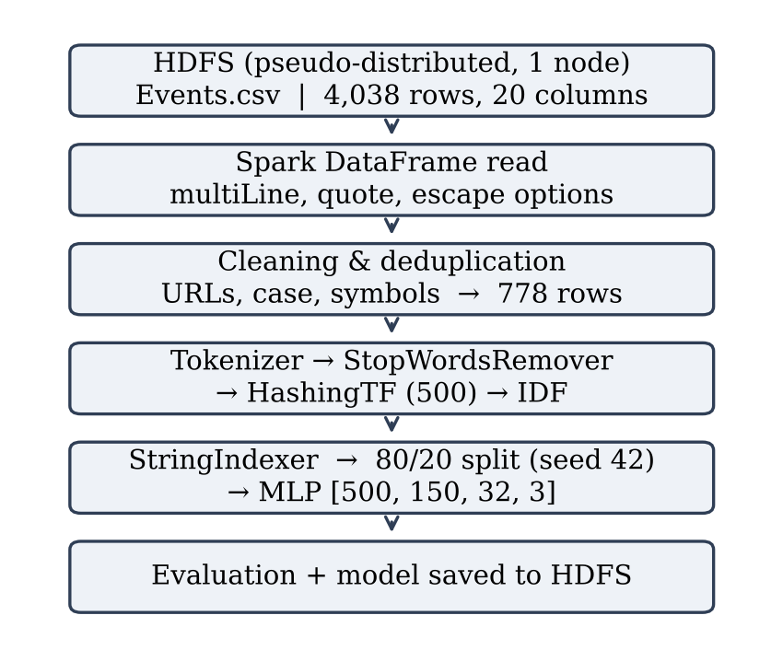
- Pipeline architecture, from HDFS storage to evaluation and model persistence.
With 778 cleaned rows, this dataset is not Big Data and would fit easily in the memory of one machine. What the project demonstrates is the workflow itself: distributed storage, DataFrame processing and MLlib modelling. Most of the pipeline would run unchanged on a larger cluster. The exceptions are the toPandas calls used for plotting and word-frequency analysis and a collect call used to count classes, because they move all the data to the driver and would need to be replaced by aggregations or samples at scale.

Methodology
The work was developed in a Jupyter notebook using PySpark, the Python interface to Spark, on a Linux virtual machine running Hadoop and Spark. The methodology followed a simple sequence: load and inspect the data, clean and deduplicate the text, extract features, encode labels, split the data, train the model, evaluate it and save it. Each step was implemented with Spark operations wherever possible, so that the same code could later be run on a cluster. Pandas and Matplotlib were used only for plotting small aggregated results.

Text Cleaning
All processing was done with Spark DataFrame functions. URLs were removed from each description, the text was converted to lower case, characters other than letters, digits and spaces were stripped, and repeated spaces were collapsed. These steps reduce noise, so that the same word is not counted as several tokens because of case or punctuation. One side effect is that the literal "\n" sequences in the raw text were removed without adding a space, so some neighbouring words were merged. Exact duplicate descriptions were then dropped, which reduced the data from 4,038 to 778 rows (678 Event, 97 Festival and 3 Market). In other words, about 80% of the raw file consisted of repeated listings, as shown in Fig. 2.
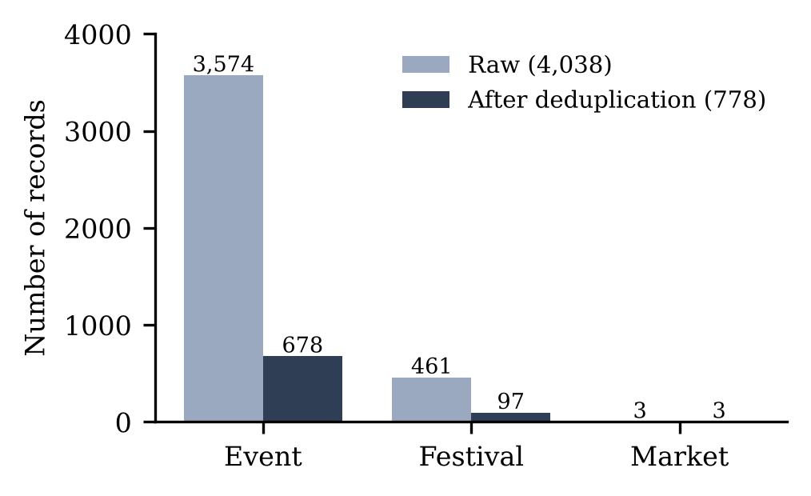
- Class distribution before and after duplicate removal.

Feature Extraction
The cleaned text was split into words with Tokenizer, and common English stop words were removed with StopWordsRemover, since words such as "the" or "and" carry little information about the event type. The remaining words were mapped to numeric vectors with HashingTF using 500 features. Hashing was chosen because it produces fixed-size vectors without storing a vocabulary, which suits a distributed setting, although a small feature space increases the chance that different words share the same index. IDF was then fitted to lower the weight of terms that occur in most descriptions, such as the standard closing sentence, and to raise the weight of more distinctive terms. Labels were encoded with StringIndexer, which orders classes by frequency (Event = 0, Festival = 1, Market = 2).

Model and Evaluation
The data was divided with an 80/20 random split and a fixed seed of 42 for reproducibility. The split was not stratified. The classifier was the MLlib MultilayerPerceptronClassifier with layers [500, 150, 32, 3]: an input layer matching the 500 TF-IDF features, two hidden layers of 150 and 32 neurons with sigmoid activations, and a softmax output layer with one neuron per class. It was trained for a maximum of 100 iterations. The layer sizes were chosen heuristically rather than tuned, so this configuration is a starting point, not an optimised model. The network was trained with the default L-BFGS solver, which updates all weights using information from the whole training set at each iteration.
An MLP was chosen over simpler linear models because its hidden layers can, in principle, learn combinations of terms that a single linear boundary cannot. The trade-off is that it has many more parameters to fit, which increases the risk of overfitting on a small dataset. This trade-off is a central theme of the discussion in Section VI.

Evaluation Metrics
Accuracy, the share of correct predictions, was used as the headline metric, but on imbalanced data it can be misleading, because a model that always predicts the majority class can still score highly (Taskiran et al., 2025). Accuracy was therefore compared with a majority-class baseline that always predicts Event. For each class c, three further metrics were computed from the number of true positives (TP), false positives (FP) and false negatives (FN):
Precision = TP / (TP + FP), Recall = TP / (TP + FN), F1 = 2 × Precision × Recall / (Precision + Recall).
Precision shows how many predictions for a class were correct, while recall shows how many true cases of that class were found. F1 balances the two. Weighted averages of these metrics, in which each class counts in proportion to its size, were also reported, since they are the default in MLlib, along with a full confusion matrix. All metrics were computed with the MLlib MulticlassClassificationEvaluator on the held-out test set.

Results
The random split produced 654 training rows and 124 test rows. The test set contains 113 Event, 10 Festival and 1 Market record, so a majority-class baseline that always predicts Event reaches an accuracy of 0.911.
The MLP reached an accuracy of 0.887, which is 2.4 percentage points below this baseline (Table I). For Festival, the model correctly classified 4 of the 10 cases and assigned the remaining 6 to Event, giving a recall of 0.400. It also predicted Festival for 4 Event cases, which results in a precision of 0.500 and an F1 score of 0.444. The single Market case was classified as Event, and all three Market predictions were incorrect, so Market scored 0.000 on all three metrics. The full confusion matrix is shown in Fig. 3.
- Per-Class and Overall Test Results
Class | n (test) | Precision | Recall | F1
Event | 113 | 0.938 | 0.938 | 0.938
Festival | 10 | 0.500 | 0.400 | 0.444
Market | 1 | 0.000 | 0.000 | 0.000
Weighted average | 124 | 0.90 | 0.89 | 0.89
Accuracy (MLP) |  |  |  | 0.887
Majority-class baseline |  |  |  | 0.911
Weighted averages are reported with two decimals, as printed in the notebook.
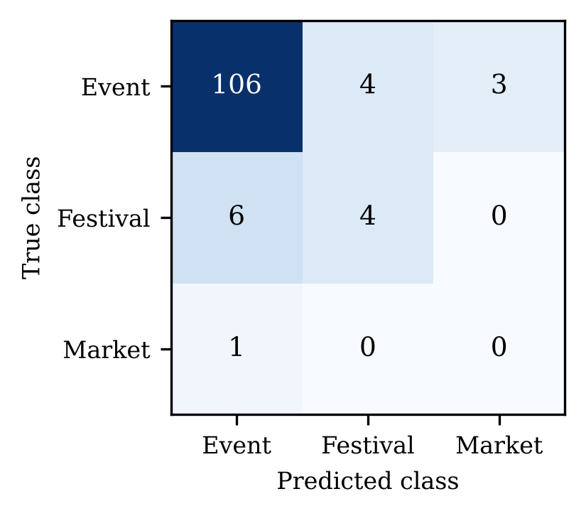
- Confusion matrix on the test set (rows: true class; columns: predicted class).
The weighted metrics (precision 0.90, recall 0.89 and F1 0.89) appear favourable, but they are dominated by the Event class, which accounts for 91% of the test set. The per-class results tell a different story, and the reasons for this gap are examined in the next section.
The errors are also not evenly spread. Of the 14 incorrect predictions, 6 were Festival cases labelled as Event, 4 were Event cases labelled as Festival, 3 were Event cases labelled as Market and 1 was a Market case labelled as Event. In other words, the model confuses the two larger classes in both directions, and it occasionally predicts Market even though only two Market examples were available for training.

Discussion
The MLP accuracy of 0.887 lies between two baselines: it is above the majority rate of the full cleaned dataset (678 of 778, or 0.871), but below the majority rate of the test set (0.911). This gap arises because the random, non-stratified split left only 8% Festival cases in the test set, compared with 12.5% overall. A single split is not enough to prove it, but this suggests that the evaluation is sensitive to how the data is divided.
Class imbalance is a likely explanation for the low Festival recall, in line with the tendency of learners to favour the majority class (Ghosh et al., 2024; Johnson & Khoshgoftaar, 2019). However, this was not tested directly. Oversampling Festival in the training set only, as compared by Taskiran et al. (2025), would show whether recall improves. Two alternative explanations are also plausible. First, the network has about 80,000 weights (500 × 150 + 150 × 32 + 32 × 3) for only 654 training rows, so overfitting is a serious possibility, and Zhang et al. (2023) also highlight the ratio between samples and features as a factor. Second, Event and Festival descriptions may share similar wording, including the same standard closing sentence, which would limit how well bag-of-words features can separate the two classes. This hypothesis could be checked by comparing the most frequent terms in each class.
Several factors limit the strength of these results. Only one configuration and one seed were used, so the effects of imbalance, architecture, hash size and number of iterations cannot be separated; repeated or cross-validated runs, as used by Lucca et al. (2017), would give more reliable estimates. The metrics may also be optimistic, because the IDF and StringIndexer stages were fitted on the full dataset before the split, which is a form of leakage described by Kapoor and Narayanan (2023). In addition, exact-duplicate removal does not catch near-identical listings of recurring events, such as one description that appeared 38 times in the raw file, so close variants may be present in both sets. Finally, with 10 Festival cases and 1 Market case in the test set, one extra correct prediction would change Festival recall by 10 percentage points, so per-class figures are unstable.
Two smaller design choices may also have reduced performance. The cleaning step merged some words where line breaks had been removed without a space, which creates rare tokens that do not match their normal forms. In addition, with only 500 hash buckets, different words are forced to share the same feature, so terms that are typical of festivals may be mixed with terms that are typical of general events. Neither effect was measured in this project, but both are easy to test by adjusting the cleaning rule and increasing the number of features.
These findings are consistent with the literature. Ghosh et al. (2024) report that the harm caused by imbalance grows when the minority class is both small and hard to separate, which matches the situation of Festival here: few examples and wording close to that of general events. Taskiran et al. (2025) and Johnson and Khoshgoftaar (2019) both recommend reporting class-sensitive metrics, and the gap between the weighted F1 of 0.89 and the Festival F1 of 0.444 shows why. In contrast with the large-scale Spark studies reviewed in Section II (Dritsas & Trigka, 2025; JayaLakshmi & Krishna Kishore, 2022), which focus mainly on runtime and scalability, this project shows that a working distributed pipeline does not by itself guarantee a useful model. Data quality and evaluation design matter at least as much as the processing framework.
The architecture itself also has limits. Because HDFS ran on a single node and the data fitted in one partition, the experiment did not test true parallelism: every stage ran as one task, and the benefits of Spark described by Zaharia et al. (2016) could not be measured. On a real cluster with much more data, several changes would be needed. The data would have to be repartitioned so that tasks are spread across executors, and intermediate DataFrames that are reused, such as the TF-IDF features, should be cached to avoid recomputing them for every action. The toPandas and collect calls would also need to be removed. HDFS replication would then provide the fault tolerance that was missing here (Shvachko et al., 2010). The current design is a sound starting point for such a deployment, but its performance at scale remains untested.
Regarding the research question, the pipeline works end to end on Spark, from HDFS storage to a persisted model, but the model in its current form does not reliably separate festivals from general events. The answer is therefore negative for this configuration, while the causes identified above point to clear and testable improvements.

Conclusion and Future Work
This project built a distributed text classification pipeline for Irish event listings using HDFS, Spark DataFrames and MLlib. Careful CSV parsing and deduplication were essential, since about 80% of the raw records were repeated. The MLP reached an accuracy of 0.887 , but it did not beat a majority-class baseline of 0.911 and recovered only 40% of Festival cases. The main lesson is that, on imbalanced data, overall accuracy can hide poor minority-class performance, and per-class metrics and baselines should always be reported.
For an organisation that wants to classify event listings automatically, the practical implication is clear. A model like this one could support editors by pre-filling a suggested category, but it should not label listings on its own, because it would miss most festivals. Reporting the per-class results alongside the overall accuracy made this risk visible, whereas the original notebook, which reported only an accuracy of 89%, suggested a much more successful model. The project also showed the value of checking every result against a simple baseline before drawing conclusions.
Future work should first remove the leakage by fitting all preprocessing stages inside an MLlib Pipeline trained on the training data only. A stratified split or cross-validation would make the evaluation more stable. Festival could then be oversampled, or class weights applied, in the training set only. The very small Market class should be merged with another category or removed. Finally, simpler baselines such as logistic regression, smaller networks and larger hash spaces should be compared, and the pipeline should be tested on a larger, multi-node cluster to evaluate its scalability.

References
Dritsas, E., & Trigka, M. (2025). Applying machine learning on big data with Apache Spark. IEEE Access, 13, 53377–53393. https://doi.org/10.1109/ACCESS.2025.3552042
Fáilte Ireland. (2024). Events [Data set]. data.gov.ie. Retrieved September 29, 2026, from https://data.gov.ie/dataset/events
Ghosh, K., Bellinger, C., Corizzo, R., Branco, P., Krawczyk, B., & Japkowicz, N. (2024). The class imbalance problem in deep learning. Machine Learning, 113, 4845–4901. https://doi.org/10.1007/s10994-022-06268-8
JayaLakshmi, A. N. M., & Krishna Kishore, K. V. (2022). Performance evaluation of DNN with other machine learning techniques in a cluster using Apache Spark and MLlib. Journal of King Saud University – Computer and Information Sciences, 34(1), 1311–1319. https://doi.org/10.1016/j.jksuci.2018.09.022
Johnson, J. M., & Khoshgoftaar, T. M. (2019). Survey on deep learning with class imbalance. Journal of Big Data, 6, Article 27. https://doi.org/10.1186/s40537-019-0192-5
Kapoor, S., & Narayanan, A. (2023). Leakage and the reproducibility crisis in machine-learning-based science. Patterns, 4(9), Article 100804. https://doi.org/10.1016/j.patter.2023.100804
Lucca, G., Sanz, J. A., Dimuro, G. P., Bedregal, B., Asiain, M. J., Elkano, M., & Bustince, H. (2017). CC-integrals: Choquet-like copula-based aggregation functions and its application in fuzzy rule-based classification systems. Knowledge-Based Systems, 119, 32–43. https://doi.org/10.1016/j.knosys.2016.12.004
Meng, X., Bradley, J., Yavuz, B., Sparks, E., Venkataraman, S., Liu, D., Freeman, J., Tsai, D. B., Amde, M., Owen, S., Xin, D., Xin, R., Franklin, M. J., Zadeh, R., Zaharia, M., & Talwalkar, A. (2016). MLlib: Machine learning in Apache Spark. Journal of Machine Learning Research, 17(34), 1–7. https://doi.org/10.48550/arXiv.1505.06807
Shvachko, K., Kuang, H., Radia, S., & Chansler, R. (2010). The Hadoop distributed file system. In 2010 IEEE 26th Symposium on Mass Storage Systems and Technologies (MSST) (pp. 1–10). IEEE. https://doi.org/10.1109/MSST.2010.5496972
Taskiran, S. F., Turkoglu, B., Kaya, E., & Asuroglu, T. (2025). A comprehensive evaluation of oversampling techniques for enhancing text classification performance. Scientific Reports, 15, Article 21631. https://doi.org/10.1038/s41598-025-05791-7
Zaharia, M., Xin, R. S., Wendell, P., Das, T., Armbrust, M., Dave, A., Meng, X., Rosen, J., Venkataraman, S., Franklin, M. J., Ghodsi, A., Gonzalez, J., Shenker, S., & Stoica, I. (2016). Apache Spark: A unified engine for big data processing. Communications of the ACM, 59(11), 56–65. https://doi.org/10.1145/2934664
Zhang, C., Soda, P., Bi, J., Fan, G., Almpanidis, G., García, S., & Ding, W. (2023). An empirical study on the joint impact of feature selection and data resampling on imbalance classification. Applied Intelligence, 53(5), 5449–5461. https://doi.org/10.1007/s10489-022-03772-1

